**Table of Contents**

1. **Overview of Request**
2. **Description of the University**
3. **Guiding Principles**
4. **The Case for On-Campus Instruction for Fall 2020**
5. **Campus Oversight of Mount Mary’s COVID-19 Response**
6. **President’s Council**
7. **Emergency Response Team**
8. **COVID-19 Task Force**
9. **Campus Response to COVID-19 Since Spring 2020**
10. **Plans for Fall 2020**
11. **General Sanitizing and Disinfecting Practices**
12. **Safe Practices**
13. **Classroom and Curriculum Modifications**
14. **Experiential Learning**
15. **On-Campus Experiential Learning in Art Therapy, Dietetics, Education, Counseling, Nursing, Occupational Therapy and Social Work**
16. **Off Campus Experiential Learning in Art Therapy, Dietetics, Education, Counseling, Nursing, Occupational Therapy and Social Work**
17. **Laboratory Safety**
18. **Performance Arts Courses**
19. **Studio Art, Fashion and Interior Design Experiential Learning**
20. **Other Campus Space Modifications**
21. **Campus Offices**
22. **Haggerty Library**
23. **Lounges & Gathering Spaces**
24. **Residence Life: Caroline Hall**
25. **Residence Life: Lorenz House and Mary John Place**
26. **Food/Food Service**
27. **Student Activities**
28. **Services to Students**
29. **Campus Store**
30. **Mail Services**
31. **Computer Labs**
32. **Library**
33. **Fitness Center**
34. **Accommodations**
35. **Employees**
36. **Employee Assistance Program**
37. **Students**
38. **Campus Communication**
39. **Illness Prevention and Prevention Protocol**
40. **Campus Visitors**
41. **Additional Comments**
42. **Contact Information**
43. **Appendices**
44. **Response to Exposure or Illness due to COVID-19 in the residence hall**
45. **Residence Hall Student Move in Process**
46. **Sample Campus Signage**
47. **Mount Mary University COVID-19 Response Protocol**
48. **Tracking and Tracing Template**
49. **Campus Community Commitment**
50. **COVID-19 Screening**
51. **Prospective Student Campus Visit Protocol**

**To**: City of Milwaukee Health Department  
**From**: Christine Pharr, Ph.D., President, Mount Mary University   
**Date**: July 28, 2020

# Overview of Request

Mount Mary University is writing this document to the City of Milwaukee Health Department to request that our University be allowed to open for on-campus and online curricular and co-curricular activities beginning on August 17th, 2020, to coincide with the beginning of our fall semester. In this memo we have delineated the rationale for our request and the measures our University has taken to keep our students and employees safe from COVID-19.

# Description of University

Mount Mary University is an urban Catholic university for women that provides an education designed towards development of the whole person. The University encourages leadership, integrity and a deep sense of social justice arising from sensitivity to moral values and Christian principles. Mount Mary commits itself to excellence in teaching and learning with an emphasis on thinking critically and creatively.

The baccalaureate curriculum integrates the liberal arts with career preparation for women of diverse ages and personal circumstances; the programs at the graduate level provide opportunities for both men and women to enhance their professional excellence. Mount Mary is accredited by the Higher Learning Commission’s North Central Association and was reaccredited in 2013. The institution holds program specific accreditation for its programs in art therapy, counseling, dietetics, interior design, occupational therapy, and social work.

Mount Mary University serves approximately 1,250 students, 48% from the city of Milwaukee, 85% from the M7 region and 91% from the state of Wisconsin. Over 60% of our undergraduate population are women of color and 55% are Pell-eligible. Thirty-two percent are first generation students who need much support to navigate the higher education system. For our students, an education is life-changing and often breaks the cycle of poverty in their families. MMU is a minority-serving institution and was recently declared a Hispanic-Serving institution by the United States Department of Education.

Mount Mary employs approximately 220 full-time or percentage employees and an additional 160 adjunct faculty each year.

# Guiding Principles

As Mount Mary plans for our return to campus in fall 2020 the following guiding principles have directed our decision making:

1. To maintain an environment where our employees and students are safe.
2. To maintain productivity for the campus through both on-campus and remote work.
3. To be able to reward employees and students for the hardship that they have endured during this time of COVID-19 challenge by keeping employees on the job and students as engaged as possible in their education.
4. To provide an optimal learning environment for our students by returning to as normal as possible a semester while also accommodating employees and students with health challenges.
5. To maintain institutional viability in the face of possible large enrollment declines in fall 2020 due to COVID-19.

# The Case for On-Campus Instruction for Fall 2020

Throughout this document, Mount Mary demonstrates the due diligence the University has completed to prepare campus for a safe re-opening. It is our position that providing a modified version of in-person instruction is necessary to educate and support the student body Mount Mary serves. Mount Mary University has devoted significant resources, time, effort and care to creating a safe learning environment that will serve our students well.

Mount Mary is known for our small class sizes and personalized attention to each and every student. We provide undergraduate and graduate education in a supportive, holistic environment that develops the whole person. As such, we teach our students not only academic content but skills to prepare them for life. This personalized education has largely been delivered on-campus in small classes in an intimate learning environment. Last spring, we pivoted online as most other schools did. This was a true challenge for our students. Many Mount Mary students live in households that do not have sufficient technology, WiFi, or a quiet place to effectively learn in an online environment. Even after offering all students in need computers and hotspots, students still expressed difficulty engaging in learning activities due to their home environments. Congested WiFi bandwidth, constant disruptions by others, and a lack of overall family support for online learning caused our students to struggle academically. Many of these same students have indicated to us that they are not coming to school this fall if the curriculum is delivered online. Much like we have seen vulnerable communities disproportionately impacted by COVID-19 diagnoses and related health concerns in Milwaukee, Mount Mary has witnessed our students from low-income households negatively impacted by the transition to online learning. Those who could benefit most from a post-secondary education are simply unable to adequately learn in an online format.

Mount Mary has demonstrated a unique ability to provide an intimate and supportive learning environment that effectively educates the type of students we serve, especially students who are first in their families to attend college and/or who live in poverty. Our students depend on us for more than just an education. For some, we are the only safe place they can go. In fact, for about ¼ of our resident students, Mount Mary is their primary home as they often have no other place to live. Again, Mount Mary provides not only access to education but also access to important life information and skill-building. Because of the practices and policies we have developed, students will learn about safe practices with regard to COVID-19 and will practice them on campus.

Thus, since May, Mount Mary faculty, staff and administration have worked diligently to develop and implement a plan for a safe environment for students and employees to return to campus in the fall. Below is an overview of the details of that plan.

# Campus Oversight of Mount Mary’s COVID-19 Response

The following groups have taken an active role in approving the policies and practices of the campus to ensure the safety of students and employees:

1. President’s Council – this group, which consists of six Vice Presidents and the President, oversees final decision making on recommendations from the groups listed below.
2. The Emergency Response Team– This group meets two times weekly for one hour to problem-solve and identify COVID-19 progress and efforts needed in the coming weeks. This group consists of President’s Council, all School Deans and representatives from Information Technology, Instructional Design, Residence Life, Building and Grounds, the Business Office, Marketing, Human Resources, Public Safety and the COVID-19 Task Force.
3. COVID-19 Task Force– This group consists of two nursing faculty, one infectious disease specialist faculty member, the Interim Director of Human Resources and the Executive Assistant to the President. The group reviews all policies and practices on campus related to COVID-19 and makes recommendations to the President and her Council.

# Campus Response to COVID since Spring 2020

As evidenced by Mount Mary’s initial rapid response to the growing COVID-19 pandemic, Mount Mary is prepared to quickly and expertly make decisions that are in the best interest of employees and students. On March 13, 2020, as COVID-19 began to sweep the United States, Mount Mary University began Spring Break with faculty and most students gone from campus. Immediately on Monday, March 16, everyone except essential staff were required to leave campus and work from home. Essential staff included Public Safety, some Building and Grounds Staff and a few Residence Life staff to manage the 40 students remaining in the residence halls. Spring Break was extended to a second week to allow time for faculty to pivot all courses to online learning. Information Technology scrambled to provide computers, hot spots and software to students and faculty to enable remote working and learning. Technological provisions were made to give all students the best access to an online education Mount Mary could provide.

For the next two months Mount Mary faculty worked with students to meet their educational needs for online learning; student support staff called, texted and emailed students to offer support and troubleshoot academic and personal issues; administrators applied for and received stimulus funds and donor support that has allowed over 780 students to get direct financial assistance for basic needs such as housing, food, transportation, insurance, medical bills, etc. It was a very challenging semester, but due to our small size and personalized attention to each student, we were able to make decisions that served our employees and students well under the circumstances.

Although some students remained in our residence halls and essential employees worked on campus since the initial closure during spring break, Mount Mary is proud to report that the precautionary measures already taken have worked; no reported cases of COVID-19 contraction as a result of being on campus have been reported. Mount Mary is certain that with an additional five months of planning since mid-March, we are prepared to resume learning and working activities in a safe environment.

# PLANS FOR FALL 2020

# General Sanitizing and Disinfecting Practices

Below are some general practices related to sanitizing, cleaning and disinfection of spaces on campus.

A. Every person will be supplied with refillable hand sanitizer (61% or more alcohol), refillable bottle of disinfectant (EPA approved 3M disinfectant RCT 40L), paper towels, multiple pairs of gloves, a washable mask and multiple disposable masks. Face shields will be provided per individual request.

B. All classrooms and public spaces (bathrooms, lobbies, public offices, etc.) will be disinfected each day. Every evening, the commercial cleaning service Mount Mary contracts with (Mahler) will clean and disinfect shared spaces using the EPA approved Diversey Virex II. This requires a 10 minute contact time to disinfect. We have also acquired a 3 minute contact cleaner that will be used in classrooms and high touch areas during the day.

C. High-touch areas (i.e. handrails, entrances, door handles and paddles, elevator buttons, drinking fountains, bathrooms) will be disinfected regularly during the day.

D. All classrooms will have disinfectant, paper towels, hand sanitizer and gloves available for students to disinfect their desks upon entry and exit; classes will end 5 minutes early to allow adequate time for disinfecting between every class period. Laboratories with equipment should be cleaned by faculty and students following use.

E. All faculty and staff offices will be supplied with disinfectant solution, hand sanitizer and paper towels to maintain office cleanliness.

F. Multiple supply stations for sanitizer, disinfectant, gloves, masks, paper towels, etc. will be located around campus to provide refills on all supplies.

G. Restrooms will have garbage cans outside the door for paper towels used to open the door.

H. Additional hand sanitizer stations were purchased and will be placed at each entrance.

I. To minimize office traffic and janitors entering offices, individuals will take recycling to stations in hallways, and garbage cans will be placed outside of office for pickup.

# Safe Practices

A. Everyone on campus must wear masks indoors and outdoors unless they are alone.

B. All public offices have Plexiglas shields between the service provider and those coming to the office.

C. All employees and students are required to check their temperature each day prior to coming to campus, and if anyone has a temperature over 100.4o they must work/learn from home. Thermometers will be available at various sites on campus for those without a thermometer.

D. Everyone on campus must practice physical distancing of at least six feet.

E. People will be asked to walk single file on the right side of the hallway to control traffic flow and maintain physical distancing.

F. Signs will be placed all around the campus reminding people of the safe practices listed above.

G. The majority of meetings will occur virtually (i.e. Zoom, Skype for Business). All meetings rooms have been labeled for reduced, physically distanced capacity which cannot be exceeded. Furniture has been removed to reinforce the new limited capacity.

H. The fountain portion of all drinking fountains on campus has been disabled but the bottle filling portion remains active. Six additional bottle filling stations have been added around campus.

I. Elevators will have signs posted to limit occupancy to two persons at a time.

J. Disinfectant wipes will be located near all shared equipment (refrigerators, copy machines, shared printers, etc.)

# Classroom and Curriculum Modifications

Mount Mary is already known for our small class sizes with 88% of all classes enrolling 20 or fewer students. To accommodate COVID-19 physical distancing requirements, we have created 104 discussion and lab sections by splitting larger classes into multiple rooms. Below are some specific measures related to instruction and curriculum that address safety:

A. Face-to-face delivery is prioritized for science and design labs, art studio courses and first-year student courses that utilize critical academic support pedagogies. See details below for experiential learning.

B. All classrooms have been re-evaluated to determine maximum occupancy with physical distancing according to City of Milwaukee Health Department definitions. No classes will exceed the revised occupancy requirements.

C. Depending on the course content, one of two methods will be used to deliver instruction in a manner that meets physical distancing requirements:

1. **Split Class in Multiple Classrooms**
   1. Students are split into smaller groups and assigned to multiple classrooms in

close proximity.

* 1. Zoom technology is used to deliver synchronous presentations to multiple

rooms.

* 1. Teaching Assistants may be present when primary faculty are working in the

alternate classroom.

2) **Split and Alternate Days on Campus**

1. Students are split into two groups that alternate their time on campus for weekly class sessions.
2. Zoom technology is used to deliver synchronous or asynchronous instruction to the group not on campus.

D. Any students who are not able to come to campus will be accommodated by providing synchronous participation via Zoom, other options for remote learning or a recorded version of the class to view at a later time. Any student requesting accommodations to attend face-to-face courses remotely will be reviewed and approved by Academic and Student Affairs team members in partnership with faculty.

E. Technology for faculty to conduct close-up demonstrations without coming close to students will be available.

F. Six new immersive and enhanced technology distance delivery classrooms will be available to provide greater options for students to choose whether to be on campus or join a course virtually.

G. The Instructional Design and IT teams are providing extensive Learning Management System and related academic technology training throughout the summer to prepare faculty to deliver instruction through multiple modalities.

H. Large meeting rooms have been turned into classrooms to allow greater social distancing, and no rentals of spaces to outside groups will occur during the fall semester.

I. In addition to face mask requirements, faculty will be offered the addition of a Plexiglas face shield. Clip-on microphones that travel with individual faculty members will enhance audio clarity for both in-person and remote students.

J. Class periods will end five minutes early to ensure additional time for safe social distancing into and out of rooms, as well as time to clean student work spaces. The additional five minutes of content will be communicated online or embedded in other course assignments.

K. All students in need of a laptop computer or hotspot for remote internet service will be provided with that technology if they are unable to be on campus.

L. Students not able to come on campus will be provided a supply kit of materials to complete hands-on experiential work from home. For example, art students will receive art studio supplies, science lab students will receive science kit supplies, fashion student will receive material and equipment to learn sewing and design techniques, etc.

M. The academic calendar for the fall 2020 semester will remain the same with an August 17 start date, although the last two weeks of the semester, beginning after Thanksgiving Break, will be delivered entirely online to avoid transmission of COVID after students spend significant time away from campus.

N. An updated course schedule will include definitions of new delivery options and classroom locations. Any changes for students will be included in their individualized schedules. Students with scheduling conflicts needing to make changes to their course selections will be supported by academic advising and the Registrar.

# Experiential Learning

1. On-campus experiential learning safety precautions for Art Therapy, Dietetics, Education, Counseling, Nursing, Occupational Therapy and Social Work:

* Students must complete the University's self-assessment health screening before arriving to campus. Students who mark "yes" to any of the health screening questions, indicating they have current symptoms related to COVID-19, or have been exposed to someone who tested positive for COVID-19, will be instructed to stay away from campus and an administrator will follow up with the student. Students who mark "no" to any of the health screening questions, indicating no symptoms and no exposure, will be allowed on campus to participate in class activities.
* Students will maintain a minimum physical distance of at least six feet from any instructors or other students.
* If physical distance cannot be maintained due to the nature of the skill being taught, both mask and face shield will be worn.
* In addition to a face shield and mask, gloves will be worn when direct contact with food (e.g., faculty touching food in dietetics) and people (e.g., students in occupational therapy practicing physical movements).

1. Off-campus experiential learning safety precautions in Art Therapy, Dietetics, Education, Counseling, Nursing, Occupational Therapy and Social Work:

* Experiential learning at off-campus sites has been approved for students this fall. Each facility has specific directions/criteria for entering the building as well as additional behavioral and safety criteria that apply to students. The experiential learning coordinator maintains communication with the sites and coordinates with the faculty to be certain that students meet those standards.
  + Art Therapy: Students have the option of choosing an internship off campus (telehealth or in-person) or completing a course and delaying their internship until next fall. The course would normally be completed next fall and the student’s load will be reduced by that course to allow for the internship experience.
  + Dietetics: Students will complete increased experiential learning on campus where possible. Students who complete hours at off-campus internship sites will follow the guidelines of the site.
  + Education: Students will complete student teaching at participating schools and follow the guidelines of the school.
  + Counseling: Students will complete either telehealth or in-person clinical internships and follow the guidelines of the site.
  + Nursing: The experiential learning experience for the RN to BSN Completion Program is with a nurse leader. Because students are already licensed RNs, they often work with a nurse leader at their place of employment and will follow the guidelines of the site.
  + Occupational Therapy: Students who complete hours at off-campus internship sites will follow the guidelines of the site.
  + Social Work: Students who complete hours at off-campus fieldwork sites will follow the guidelines of the site.

1. Laboratory Safety

Certain laboratories require face-to-face meetings in order to provide students with proper experiential learning opportunities to reinforce classroom learning and grow as scientists. These laboratories include Chemistry, Biology, Food Science Chemistry and Physics. Multiple safety measures will be adopted in the labs, including the following protocols that will be in effect in science classrooms and laboratories:

* Students and instructors will wear masks at all times and maintain at least six feet of physical distance from others.
* If physical distance cannot be maintained, as in the case of an instructor assisting a student with specific hands-on skills, both mask and face shield will be worn.
* Laboratory room occupancy limits will be decreased to 10 students so six feet of physical distancing can be maintained. In large sections of over 10 students, a hybrid approach will be adopted with half of the class working in the lab one week while the other half works remotely. Students not able to be in the laboratory classroom due to accommodations will have supplies mailed to them.
* All pre-lab work will be done remotely to minimize the time students are working in lab.
* Specific laboratories that can be performed as data analysis experiences instead of face-to-face labs will be identified and developed where possible.

1. Performance Arts Courses

* Physical Education and Dance classes will take place in the Bloechl Center, our large gymnasium. Music courses occur in rooms that are arranged for appropriate spacing of instruments and students. All courses are at or below eight students per course, which far exceeds the requirement for physical distancing.

1. Studio Art, Fashion and Interior Design Courses

* The maximum capacity for Studio Art courses is 12 students in a classroom, and many have eight. Most classes are split into two rooms, and one is flipped to partially online (watercolor). In other studio environments like Fashion, we have split students into multiple rooms with a maximum of seven students in any hands-on studio class. Interior Design maximum studio occupancy is 12 with students spread out across the room appropriately.

# Other campus space modifications:

1. Furniture in offices with multiple employees will be distanced more than 6 feet apart.
2. Haggerty Library stacks are well spaced for social distancing and thus the stacks and checkout will remain open as normal with shortened hours. Additionally, the library will place markings on the floor to remind students of the need to maintain physical distance and to control the traffic flow. Hand sanitizer and disinfectant wipes will be available for patron use. Bins will be provided for patrons to return books borrowed but not checked out. The library will have chairs removed so that fewer people can sit at tables and all patrons can be appropriately physically distanced.

C. Student and employee lounge areas will be modified to provide spacing between   
 chairs of at least six feet. Markers on the floor and tables will indicate the   
 appropriate distance.

1. Select computers in all computer labs will be made inoperable by removing   
    keyboards and mice so computer users are appropriately physically distanced.
2. Computer labs will have cleaning supplies located next to keyboards for cleaning prior to use.

D. Residence Life: Caroline Hall

At this time 164 students have signed housing contracts for Caroline Hall, our undergraduate residence hall, for the fall 2020 semester. We have a bed capacity of 260 in Caroline Hall and do not intend to fill it in an effort to provide ample space for appropriate physical distancing. Safety measures for residence halls are listed below:

1. The residency requirement for first-year students has been lifted for this academic year.
2. Flexibility on housing contracts will be granted for students as they make personal choices about living on campus, including prorated rates and refunds for students who either wish to cancel or opt into on-campus housing.
3. Only single and double occupancy options will be available. No triple occupancy rooms will be filled to capacity.
4. Most residence hall rooms have a private bathroom in their living space or share a bathroom between two living spaces.
5. Fewer students will be assigned to floors with community bathrooms. The community bathrooms will be professionally cleaned daily, and cleaning supplies will be present in each bathroom for student use.
6. Lounges in the residence hall will be assigned a maximum occupancy. Occupancy will be strictly enforced by Resident Assistants (RAs) and resident hall administrators.
7. All resident students will be provided with their own cleaning supplies, disinfectants, masks, hand sanitizer and thermometers.
8. No non-resident student visitors will be allowed in the residence hall.
9. All resident students must complete a COVID-19 planning document prior to move-in. This form requests students to identify their primary care physician (PCP) and asks them what they intend to do if they become diagnosed with COVID-19 or have had significant contact with someone who tested positive for COVID-19.

a. Anyone lacking a PCP will be referred to Progressive Community Health Center which has an arrangement with MMU to treat those students without a doctor or health insurance.

b. If a student tests positive for COVID-19, they must either reside in the designated quarantine area or return home until the Milwaukee Health Department confirms it is safe for the student to return to their normal residence hall room.

1. Each room will have safety and reporting protocols posted as daily reminders for students about what is expected of them while interacting on campus, and/or if they are ill or have had significant contact with someone who is ill. **A detailed plan for both of these scenarios is found in Appendix A**
2. Eight single-occupancy residence hall rooms on a designated wing of Caroline Hall have been sectioned off and reserved in case students need to quarantine in accordance with Health Department guidance. MMU staff will check on students to monitor and ensure students are interacting with medical professionals, including the Health Department. Meals will be delivered to these students.
3. Special move-in procedures designed to significantly reduce physical proximity to others and minimize traffic flow have been provided and will be strictly enforced. A letter is being sent to all Caroline Hall residence students that gives them guidance about move-in appointments, creating a COVID plan prior to arrival on campus, and processes for moving into the residence hall. This can be found in **Appendix B.**

1. Residence Life: Lorenz House and Mary John Place
   1. Lorenz Place is a small house located on the Mount Mary campus that houses three undergraduate students. These three students will be treated as a family unit and supplied with cleaning supplies to regularly disinfect their house. Students have the ability to quarantine in their own rooms in the Lorenz House.
   2. Mary John Place is an apartment building owned by the University and adjacent to the campus. It has four separate apartments and holds a maximum of eight graduate students. Each apartment will be treated as a family unit. All units will be provided with disinfecting supplies.

F. Food/Food Service

Students and employees will be allowed to eat in our very large (7,920 sq. ft.) dining room. Below are the protocols for dining:

1. All food will be served by food service employees who are masked and gloved. There will be no self-service.
2. A grab-and-go station will allow students to purchase prepared food without eating in the dining room.
3. Seating in the dining room has been decreased to a maximum capacity of 102 people at any one time. This allows adequate social distancing. No more than that will be allowed in the dining room at any one time.

G. Student Activities

Student activities that provide the opportunity to meet others and build community will be offered with precautionary measures in place. Outdoor events that allow for adequate physical distancing and virtual events where students can engage safely from their homes or residence hall rooms are planned. No field trips will be allowed until federal, state and local health officials determine it is safe to resume these activities.

# Services to Students

### 

1. Campus Store

The bookstore will provide books online with delivery to campus or their home. It will be open for other purchases with limited hours and will require masks and physical distancing.

2. Mail Services

Open Monday-Friday 8 a.m.–4:30 p.m. All normal services available.

3. Computer Laboratories

Computer labs will remain open with alternate computers disabled in order to maintain physical distancing. Keyboards and mice will be removed from those computers not available for use. Disinfectant wipes will be placed near each operable computer to allow for wiping the keyboard following each use.

4. Library

Library circulation will remain open with published hours. Students must make a request for materials at the Help/Circulation Desk for retrieval. Other guidelines, such as those noted above, will be posted and published in order to achieve and maintain appropriate social distancing.

* Counseling Services

Students in need of mental health counseling will have the opportunity to meet with a counselor in person in a large but private conference room. Students also have the option of meeting virtually with a counselor if they prefer not to do so in-person.

* Academic Support Services

Similar to counseling services, academic support such as tutoring, accessibility services, advising, career development and faculty office hours can be delivered both in-person and virtually depending on preferences of the student and service provider.  For in-person appointments, students and MMU personnel will be divided by at least six feet of distance and/or by a Plexiglas shield.

* Business Services

Business service transactions, such as financial aid, registration, and tuition payments can also be completed through multiple modalities.  Again, for any in-person transactions, students and MMU personnel will be divided by at least six feet of distance and/or by a Plexiglas shield.

5. Bloechl Center  
 The fitness center remains closed at this time. Should it open during the fall, there   
 will be strict safety and cleaning protocol enforced.

# Athletics

1. Mount Mary University belongs to the Coast 2 Coast (C2C) Athletic Conference, which only allows the opportunity for post-season play. During the regular season we rarely compete with anyone in our conference. The C2C conference has made the decision to cancel conference play for fall sports for this year.
2. Mount Mary has not made a decision about holding fall sports at this time. We are researching the situation and will decide soon. If we do compete, we will abide by the recommendations of the NCAA for testing weekly.

# Accommodations

Various types of accommodations will be made for employees and students. Information about where to submit accommodation requests is being delivered to both groups via multiple electronic and postal mail formats.

1. All employees were sent a survey and required to complete it indicating their need for documented accommodations related to health conditions or other needs. Samples of accommodations that will be honored include:
2. The health of the employee
3. The health of a family member with a medical condition living with the employee
4. Lack of school or child care.
5. For benefits eligible employees (those working 30+ hours/week), as well as their dependents (including children to age 26) and all household members, the Employee Assistance Program (EAP) is available for those suffering from anxiety, mental health issues or just needing information related to COVID-19. This is a free, confidential benefit through Standard Insurance Company. The website has a wide variety of information regarding COVID-19, including videos, guides, articles, webinars and resources. Master’s-degreed clinicians are available 24/7 by phone, online, live chat, email and text - the program includes up to three face-to-face assessment and counseling sessions per issue. Contact Information for Mount Mary EAP is

Phone: 888-293-6948  
Email: Workhelathlife.com/Standard3

C. Student accommodations are handled by various offices depending upon the need.   
 Students have been made aware that MMU personnel are available to process their   
 requests for alternative learning and student life arrangements.

1. Disability-related accommodations will be managed by the Director of Accessibility Services at MMU-access@mtmary.edu.
2. Residence hall accommodations will go to the Assistant Director of Student Engagement and Residence Life at reslife@mtmary.edu.
3. Academic preferences to learn remotely that are not disability-related will be directed to Academic Affairs at mmu-academicaffairs@mtmary.edu.
4. Questions and accommodations related to athletics will go to mmu-athletics@mtmary.edu.
5. All other miscellaneous requests will go to mmu-president@mtmary.edu, where they can be routed to the appropriate personnel.

# Campus Communication

A. A link to the Fall 2020 updates on the Mount Mary website is revised each Monday. It lists plans for re-opening in the fall and all safety requirements that will be implemented. This can be found at https://mtmary.edu/resources/returning-to-campus.html.

B. Each Monday the daily announcement highlights changes to the Fall 2020 plan and provides a link for the entire campus to the Fall 2020 updates at this website: https://mtmary.edu/resources/returning-to-campus.html.

C. Multiple videos are in production by an infectious disease specialist and a facilities manager that demonstrate precautionary measures and describe best practices for campus safety such as how the facilities are physically distanced, how to wear a mask correctly, etc. Faculty will show these videos to students and they will also be shared with employees. The videos will be available by the start of school. A sample video link can be found at:   
https://www.youtube.com/watch?v=jmU7tm76KKk&feature=youtu.be.

D. The President sends emails to the entire campus explaining decisions and providing updates on work in progress on preparations for fall 2020.

E. The President holds weekly Zoom meetings open to the entire campus. Typically 100 or more people participate and the majority of the topics center around COVID-19 and safety for the campus. Employees and students can ask questions, make suggestions or express concerns. All employees and students are invited and the session is recorded and posted for those not present.

F. Signs have been posted throughout campus in both English and Spanish as a reminder of best practices for preventing the spread of COVID-19. Samples can be seen in **Appendix C.**

G. Cases of non-compliance with published policies will be subject to the following and are enforceable through existing employee and student handbooks:

1. Reminders of the policies and issuance of protective supplies.

2. Escort off campus or to their residence hall room by Public Safety.

3. Student conduct hearing or employee disciplinary action.

H. Approaches to reminding people on campus about safety protocols will be distributed to faculty and staff. In addition, an anonymous reporting system will be set up to allow violations to be reported privately so the situation can be quickly addressed.

# Illness, Exposure and Prevention Protocol

1. Mount Mary University has followed the recommendations and guidance of the City of Milwaukee Health Department and the CDC in all COVID-19 response procedures. The Health Department has been advising MMU consistently on any matters related to COVID since March 2020. The University will continue to follow their guidance and direction moving forward.
2. Protocols have been developed and followed in all COVID-19 related illnesses to this point. These protocols are outlined in **Appendix D** and apply to the following:   
     
   1. Protocols for an employee or a student testing positive for COVID-19 if they have been on the Mount Mary campus within the last two weeks

2. Protocols for an employee or a student who has a family member diagnosed with COVID-19 or who has had significant contact with someone diagnosed with COVID-19.

1. **A template for reporting has been developed for tracking and tracing of students and employees. The student form (which is similar to the employees from is found in Appendix E.**
2. Mount Mary has had no student cases of COVID-19 on campus since the pandemic occurred despite having nearly 40 students in the residence hall all spring semester.
3. Two employees have acquired COVID from their families and despite the fact they were on campus immediately prior to diagnosis, no one working near them contracted the virus due to the extreme safety measures we have in place.
4. Mount Mary will not be doing routine COVID-19 testing but will direct any students or employees who show symptoms to take a test. Options for free testing will be made available to students. Until the test results are confirmed and any resulting necessary protocols have been followed, anyone with symptoms must self-quarantine.

# Campus Visitors

1. Anyone coming to campus as a visitor must complete a survey prior to arrival (see **Appendix G)** and take their temperature. If their answers are acceptable, they are given the green light to come to campus as long as they abide by our rules and regulations which are provided to them. People arriving on campus who have not received the survey in advance are required to complete the survey upon arrival. A QR code is available inside the entrance for them to use to access the questionnaire.
2. Prospective students and their families may visit campus after completing the questionnaire and reading the guidance found in **Appendix H**. Virtual visits are also offered for students and families preferring that option.
3. Faculty have been discouraged from bringing in speakers in person and instead using virtual speakers via Zoom.

# Campus Commitment A Mount Mary University Campus Community Commitment document has been created that will be circulated to all employees and students. It makes the case for following protocol to keep the campus safe because we care about each others. This commitment outlines the expectations of all members of the campus community. This document can be found in Appendix F.

# Additional Comments

Mount Mary University will continue to monitor the COVID situation on campus, locally and statewide to determine the necessity of modifying our practices as the situation evolves. All decisions will be made in alignment with the recommendations of the CDC and the City of Milwaukee Health Department. The safety and welfare of our employees and students is our #1 priority, and our practices will continue to develop the best possible solutions to address that concern.

# Contacts for Additional Information

|  |  |  |
| --- | --- | --- |
| **Academic Affairs** | **Dr. Karen Friedlen** | **414-930-3698** |
| **Student Affairs** | **Nicole Gahagan** | **414-930-3284** |
| **Financial Aid** | **Angela Sarni** | **414-930-3431** |
| **Admissions** | **Dave Wegener** | **414-930-3506** |
| **Business Office** | **Sharon Roob** | **414-930-3129** |
| **Registrar** | **Mary Karr** | **414-930-3251** |
| **Marketing & Communications** | **Kathy Van Zeeland** | **414-930-3552** |
| **Athletics** | **Natalie Balleto** | **414-930-3493** |
| **Dining Services** | **Bob O’Keefe** | **414-930-3201** |
| **Cleaning and Facilities** | **Gary Koenen** | **414-930-3534** |
| **Public Safety** | **Paul Leshok** | **414-930-3305** |
| **Space Use** | **Beth Bartelt** | **414-930-3573** |
| **Library** | **Dan Vinson** | **414-930-3494** |
| **Residence Halls** | **Julie Schneiter** | **414-930-3324** |
| **Human Resources** | **Sue Sroor** | **414-930-3574** |

# APPENDIX A: Response to Exposure or Illness from COVID-19 in Residence Hall.

**COVID-19 Response Protocol in Caroline Hall**

**Resident Assistants**

**If a residential student receives a positive COIVD-19 test result:**

* Students who test positive must immediately notify the Resident Assistant (RA) on duty by calling the RA on-duty phone.
* The RA collects basic information (student name, ID number, room number). (The Vice President for Student Affairs (VPSA) will do a complete intake of information.)
* The RA must notify the professional staff on duty immediately via phone.
* The RA should direct the student to immediately self-isolate until directed otherwise. Isolation options are as follows:
  + If a student prefers to isolate off campus, she can go home.
  + If the student lives in a room by themselves with their own bathroom, she can remain isolated in their room.
  + If the student lives in a room without a private bathroom, she must be relocated to an isolation room.
  + If the student has a roommate, the positive student must be relocated to an isolation room.
* If a student relocates to an isolation room, she must pack enough belongings for at least 14 days. Students will not be allowed to re-access their room until given clearance by a medical professional.
  + There will be a “Welcome to Isolation” information packet in the room. These documents will outline self-isolation rules and the services MMU will provide to the student while she recovers on campus (e.g. food deliver, mail delivery, virtual academic support, virtual mental health support).
  + Students’ rooms will be “bottom locked,” so no one but a residence hall staff member or campus safety can access their room.
* If the student who tested positive has a roommate, the roommate must immediately quarantine until she can get tested for COVID-19. If the room does not have its own bathroom, the roommate must relocate to a quarantine room or return home until directed otherwise.
* The VPSA will contact the student(s) to complete the full intake process and begin contact tracing.

**If a residential student has been in significant contact with someone who tested positive for COVID-19:**

* Students who have been in significant contact with someone who tested positive for COVID-19 must immediately notify the Resident’s Assistant (RA) on duty by calling the RA on-duty phone.
* The RA collects basic information (student name, ID number, room number). (The Vice President for Student Affairs (VPSA) will do a complete intake of information.)
* The RA must notify the professional staff on duty immediately via phone.
* The student must contact their medical provider and the City of Milwaukee Health Department to determine whether they need to be tested. Meanwhile, they must quarantine.
* The RA should direct the student to immediately self-quarantine until directed otherwise. Quarantine options are as follows:
  + If a student prefers to quarantine off campus, she can go home.
  + If the student lives in a room by themselves with their own bathroom, she can remain quarantined in their room.
  + If the student lives in a room without a private bathroom, she must be relocated to a quarantine room.
  + If the student has a roommate, the positive student must be relocated to a quarantine room.
* If a student relocates to a quarantine room, she must pack enough belongings for at least 14 days. Students will not be allowed to re-access their room until given clearance by a medical professional.
  + There will be a “Welcome to Quarantine” information packet in the room. These documents will outline self-quarantine rules and the services MMU will provide to the student while she recovers on campus (e.g. food deliver, mail delivery, virtual academic support, virtual mental health support).
  + Students’ rooms will be “bottom locked,” so no one but a residence hall staff member or campus safety can access their room.
* If the student who tested positive has a roommate, the roommate must immediately quarantine until she can get tested for COVID-19. If the room does not have its own bathroom, the roommate must relocate to a quarantine room or return home until directed otherwise.
* The VPSA will contact the student(s) to complete the full intake process and begin contact tracing.

**Pro-staff follow up:**

* When following up on a reported positive case or exposure to a positive case, the professional staff on duty should complete the following tasks immediately upon learning of the situation:
  + Write an email describing the interaction with the residential student, providing as much information as possible, to both the Director of Student Engagement & Residential Living and Vice President for Student Affairs and Cc the mmu-studentaffairs@mtmary.edu email address.
  + Briefly summarize the incident in the pro-staff duty log.
  + If there are multiple residential students that have been exposed to someone that tests positive, call the Director of Student Engagement & Residential Living on her cell phone and she can determine if extra steps need to be taken or if the Vice President of Student Affairs needs to be consulted immediately.

# APPENDIX B: Residence Hall Student Move-in Process

Hello!

We're so excited that you'll be living on campus in Caroline Hall this fall! You'll love being a part of our lively, close-knit residence hall community.

Below you'll find details about move-in. Please be sure to read the information carefully and complete al forms linked below.

**Move-In Day for New Students**

**Move in Instructions**

**Saturday, August 19th, 2020**

Due to COVID-19 move in will look a little different this year. Even with these changes, we are so excited to have you here! If you have any questions about the University's COVID Policies click HERE or contact Bryn Mulroy Bowden at bowdenb@mtmary.edu.  

Before Move in:

* Please sign up HERE for a move in time.
* Please fill out our My COVID Plan Form HERE BEFORE your arrival to campus.
* Please box up and label your belongings with your name and room number.

On Move-In Day:

* Complete the COVID Symptom Screening Form no more that 24 hours before arrival on campus. If you are bringing family members or guests to campus, each of your guests must complete this screening as well.
* When arriving to campus on Move-In Day, please use the 92nd Street entrance between Burleigh and Center. Click here for a map of where you should pull up to unload- we'll also have directional signs on campus.
* If you feel ill or may have been exposed to COVID-19, we request that you notify mmu-reslife@mtmary.edu and do not come to campus for your move in.
* You will be required to wear a mask during your visit to Mount Mary. We are happy to provide you with a mask if you do not have your own. Children under two years of age do not need to wear masks. If you are unable to wear a mask due to a medical or physical condition, we ask that you schedule a virtual visit at mtmary.edu/visit instead of coming to campus.
* There is a limit of 2 guests per student moving in.
* While you may stand and sit near your family members, please maintain six feet of distance from others not in your family/group while on campus.
* Please do not hug, shake hands with, or touch others on campus.

We can't wait to welcome you to campus and help make your move-in process as smooth as possible. If you have questions, feel free to contact the Office of Residence Life.

See you on August 8th!

APPENDIX C: Sample Campus Signage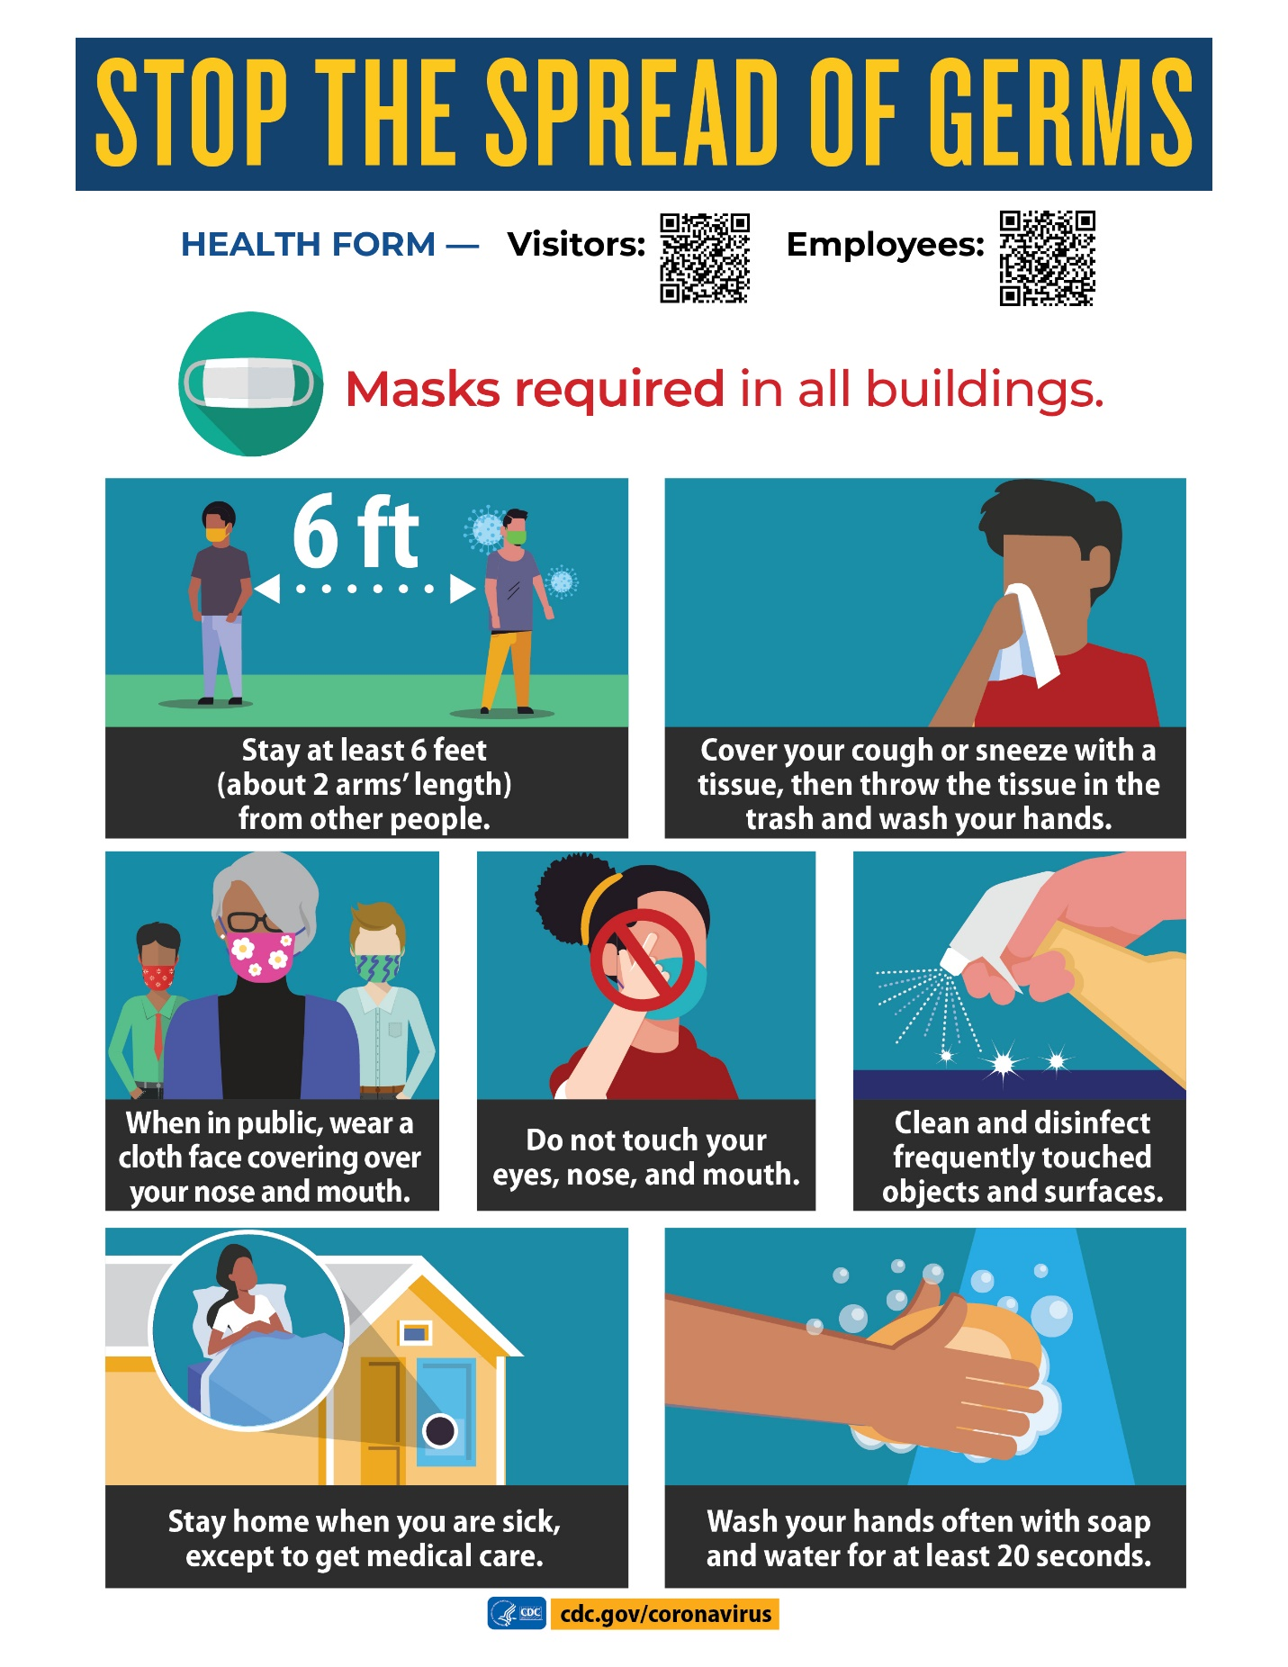

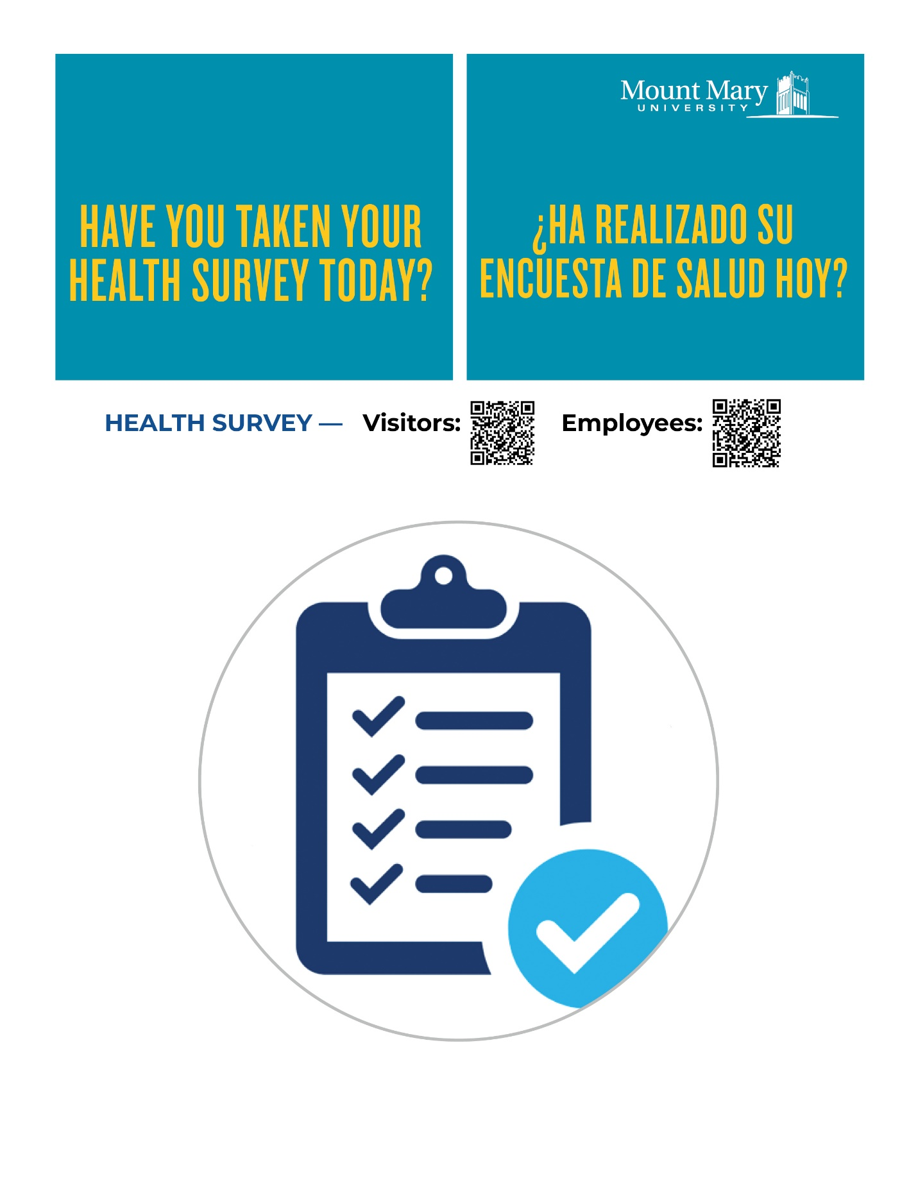

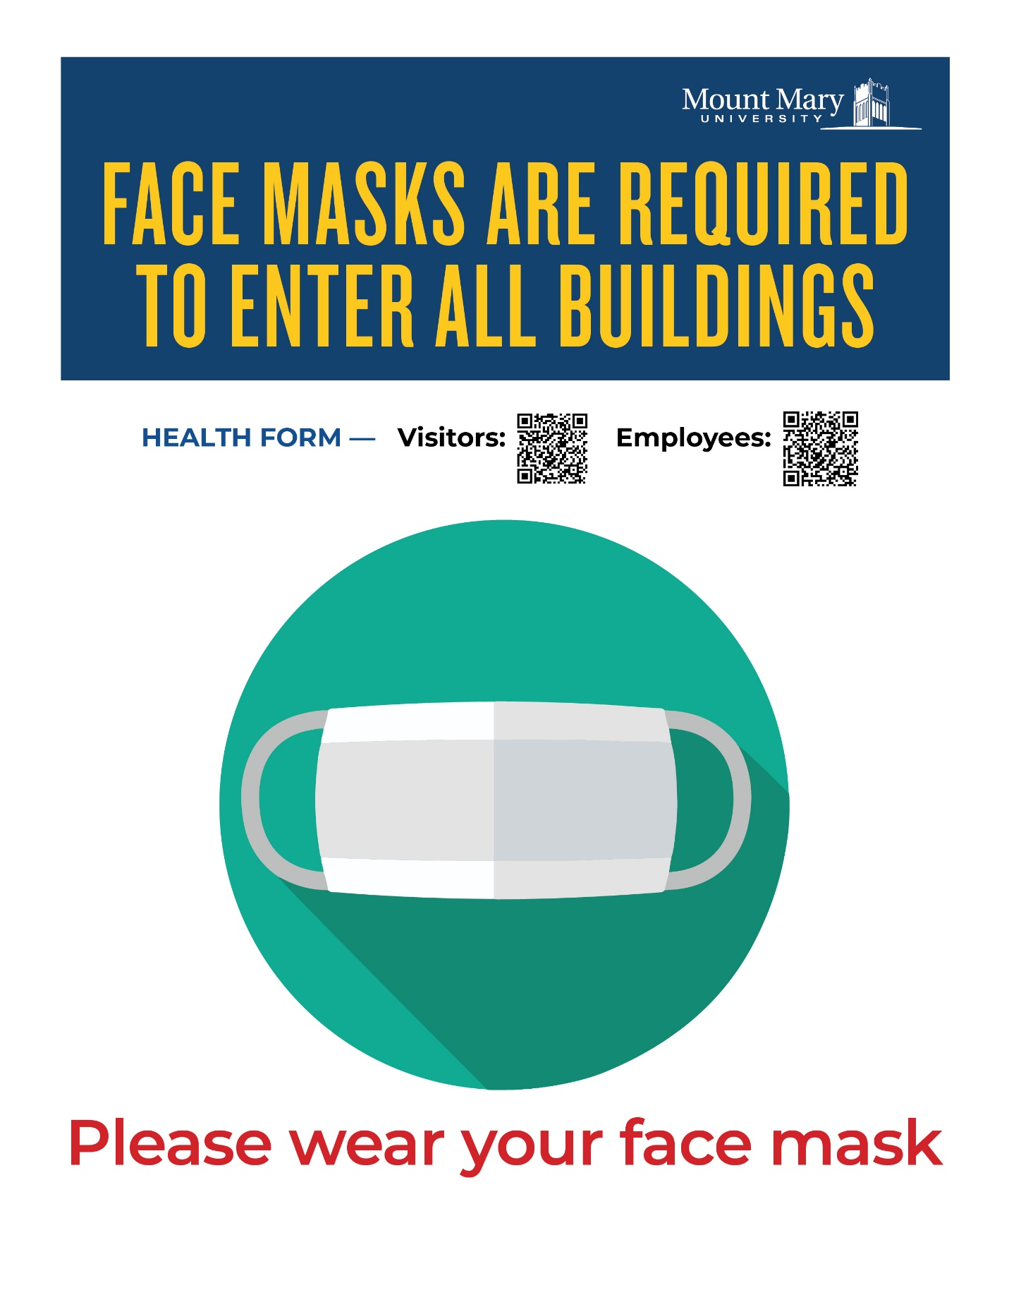

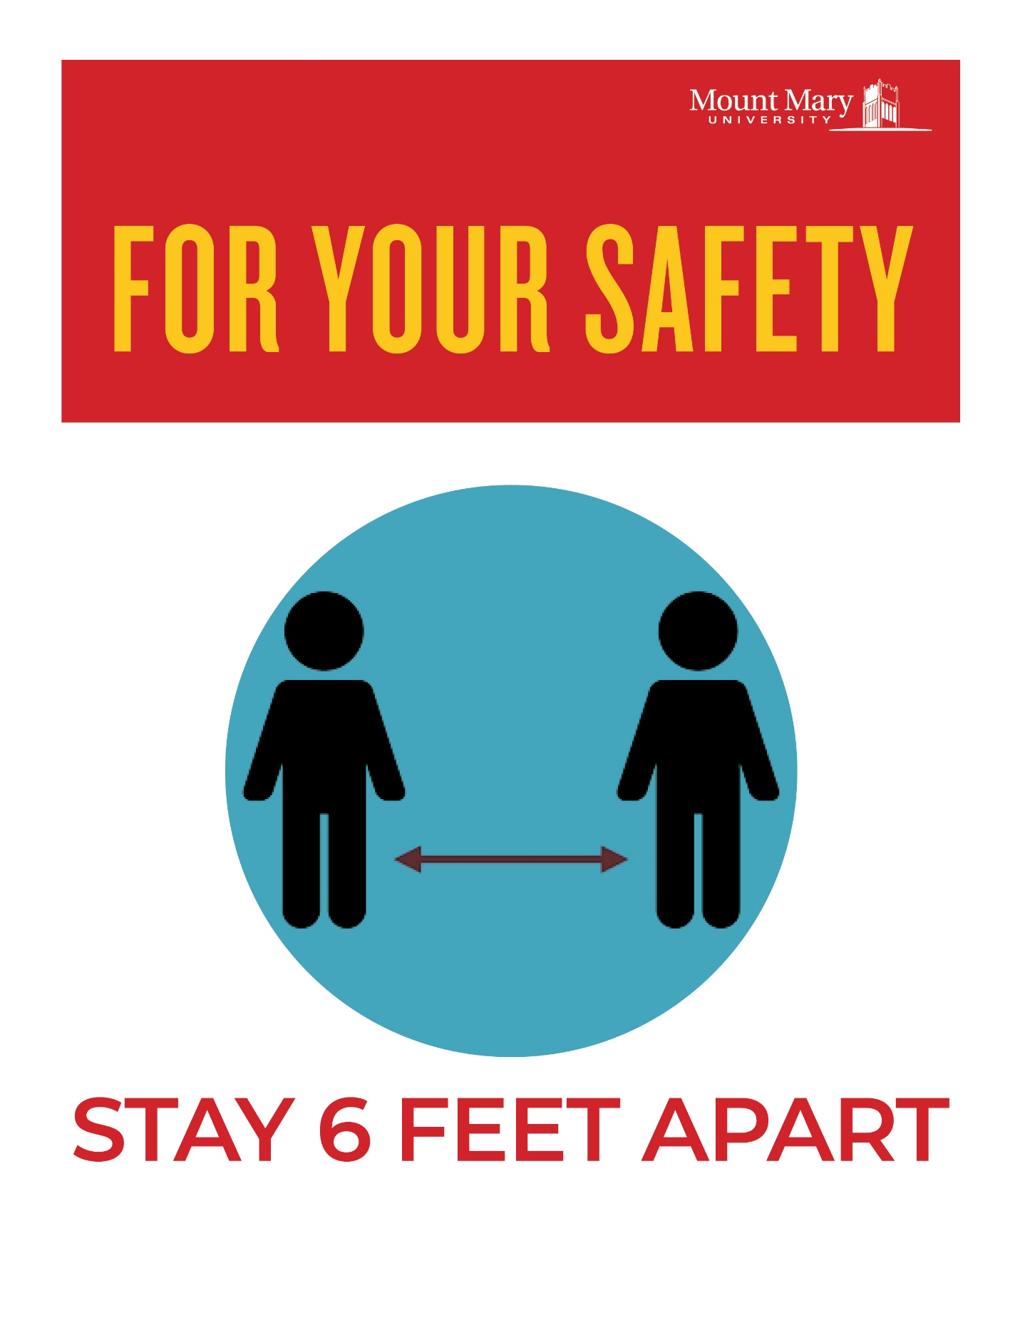

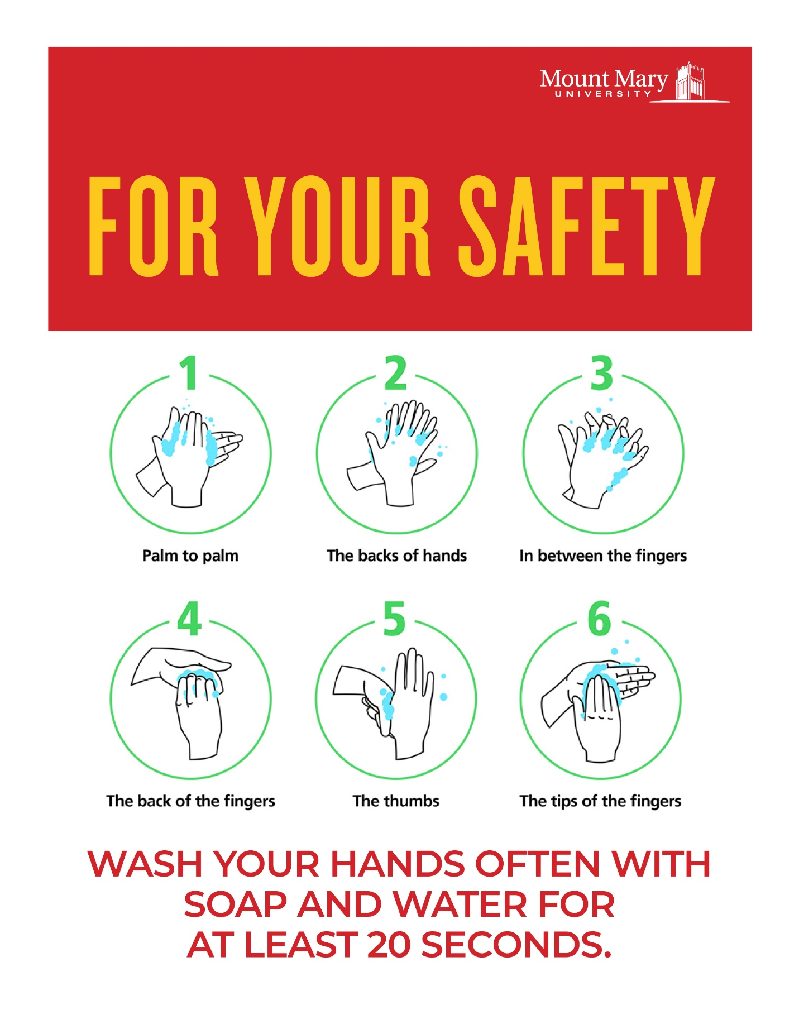

# APPENDIX D Mount Mary University COVID-19 Response Protocol

Mount Mary University will follow the recommendations and guidance of the Milwaukee County Health Department and the CDC in all COVID-19 response procedures. The Health Department has been advising MMU consistently on any matters related to COVID since March 2020 and we will continue to follow their guidance and direction moving forward.

**The Health Department recommends that if a student or employee is exposed or diagnosed with COVID-19, they will be asked to self-disclose their exposure or condition to Human Resources (for employees) and the VP of Student Affairs (for students).** This is for the protection and safety of everyone and it will be handled with care and compassion for everyone involved. Any medical information shared with MMU personnel will be kept as private as possible while still allowing MMU personnel to clean and sanitize the physical areas impacted as well as complete required contact tracing in partnership with the Milwaukee County Health Department.

**Definitions:**

* Self-Isolation – separates people with COVID from people who are not sick
* Self-Quarantine - separates and restricts the movement of people who were exposed to a contagious disease to see if they become sick.
* Significant contact is defined by the health department as 1) being within 6 feet of one another for a period of 10 minutes or longer AND 2) not wearing masks during that time in close proximity. There is not significant contact if BOTH criteria listed are not met.

**Steps to Take**

* If an Employee or Student has a positive Covid-19 test result:
  + The positive person must notify HR or student affairs through email or call to HR office or Student Affairs Vice President.
  + They are required to self-isolate for a period of minimally 14 days from the date of the positive test.
  + They will return to work per the CDC when: 1) they have no fever for at least three (3) days (72 hours) without using a fever-reducing medicine AND 2) their respiratory system symptoms (e.g.; cough, shortness of breath) have improved and they can breathe more easily AND 3) at least ten (10) days have passed since symptoms first appeared. **MMU will require a release from the health department and/or the employee’s/student physician to return to work.** The local health department in partnership with MMU, will determine if this timing should be extended based on an individual’s circumstances and symptoms as dictated by their current health situation.
  + HR or student affairs notifies the Milwaukee County Health Department of the positive result immediately upon notification.
  + HR/Student Affairs conducts contact tracing of the employee; inclusive of all areas of campus that were physically touched by the positive employee/student and the people the employee/student came into contact with on campus while they were contagious.
    - HR/Student Affairs notifies all those employees or students that had **significant contact** with the positive employee/student and the those impacted are to self-quarantine and work from home for 14 days; they must also be symptom free to return to work
    - HR/Student Affairs notifies all those employees/students that had some contact but **did not have significant contact** with the positive employee to let them know of possible exposure. These employees/students will not be required to self-quarantine but it will be recommended that they continue to practice social distancing, mask wearing and work remotely as much as possible.
    - HR/Student Affairs notifies the Director of Buildings and Grounds, President and VP of Administrative Services-CFO of the positive report and all areas that have been possibly exposed.
    - The Director of Buildings and Grounds manages the cleaning and disinfecting of all areas exposed on campus
    - HR/Student Affairs may need to notify and work with the employee’s supervisor/student’s course instructors to better assess the areas of campus and people-contact the employee had leading into illness
    - HR/Student Affairs manages all communication with the employee/student until such time that a release to work notice is received the individual may return to work
* If an Employee/Student shares a household with someone who has a positive Covid-19 test result or has significant exposure to someone who is Covid-19 positive:
  + The household-positive employee/student must notify HR/Student Affairs through email or call to HR office or student affairs.
  + They are required to self-quarantine at home for a period of minimally 14 days from the date of the household-positive test.
  + If they continue to live with the COVID positive person they will be required to quarantine for 14 days after the last contact with the COVID positive person even if they have a negative test. Thus the quarantine may extend a second 14 day period. **MMU will require a release from the health department and/or their physician and/or a negative test result to return to work.** The local health department in partnership with MMU, will determine if this timing should be extended based on an individual’s circumstances as dictated by their current household health situation.
  + HR/Student Affairs conducts contact tracing of the household-positive employee/student; inclusive of all areas of campus that were physically touched by the household-positive employee/student and the people the employee/student came into contact with on campus while the household member was contagious.
  + HR/Student Affairs notifies all those employees/students that had **significant contact** with the household-positive employee/student to notify them of possible exposure.
    - The significant-contact employee/student is asked to monitor their symptoms and report if symptoms occur.
    - HR/Student Affairs does not notify other employees that did not have significant contact with the household-positive employee.
    - HR/Student Affairs notifies the Director of Buildings and Grounds, President and VP of Administrative Services-CFO of the household-positive report and all areas that have been possibly exposed.
    - The Director of Buildings and Grounds manages the cleaning and disinfecting of all areas exposed on campus
    - HR/Student Affairs may need to notify and work with the household-employee’s supervisor/student course instructors to better assess the areas of campus and people-contact the employee/student had leading to potential exposure
    - HR/Student Affairs manages all communication with the household-positive employee/student until such time a release to work notice is received and the individual can return to work/classes

The employee’s/student’s name will not be disclosed to others, but rather that there was exposure to someone that tested positive for COVID-19 and that the person notified did or did not have significant contact with the COVID positive person. Physical spaces on campus will be adjusted and/or closed for interim time periods if needed to allow for proper disinfecting.

This instruction list is not meant to cover all situations, but rather outline our current processes and protocols for COVID-19 exposure. MMU will continue to work with the local health authorities and follow CDC guidance. MMU may adjust this protocol to be alignment with new and developing guidance as needed. Should you have any questions regarding MMU’s protocol, please reach out to the Human Resources department.

# APPENDIX E: Tracking and Tracing Template

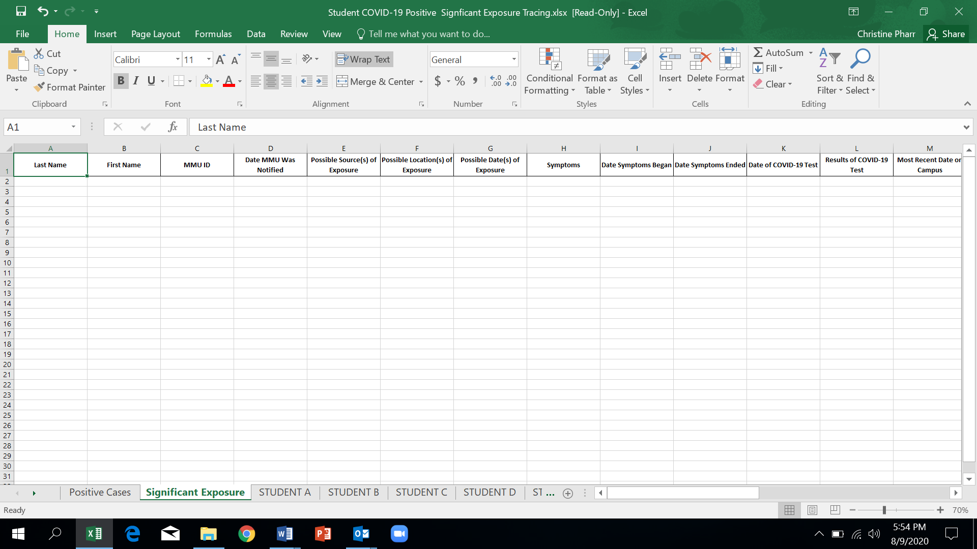

# APPENDIX F: Campus Community Commitment

# 

# Mount Mary University: Our Commitment to Community

In order to maintain a positive, healthy environment to learn, work, and live, our University has enacted precautionary measures to keep our campus safe. This commitment to caring for one another is shared by everyone in the Mount Mary community, including students, employees, and visitors. We look forward to your participation in this unified effort.

# Background

A Mount Mary University education reflects a core group of values distinguished by the characteristics   
of competence, community, compassion and commitment. Hallmarks of these values include:

1. A shared sense of purpose within the Mount Mary environment to work in the spirit of the School Sisters of Notre Dame by creating a better world through education.
2. A deliberate approach to advancing the universality of human dignity by encouraging leadership in the areas of personal development and global change.

Our very first priority during a global pandemic is taking all necessary precautions to keep our community safe and healthy. For that reason, it is imperative that you adhere to the guidelines outlined below in order to participate in campus learning, employment, and other activities.

With your commitment, we will continue to focus on providing a quality mission-centered education and individualized support services to ensure student success.

We understand there will be a period of time where Mount Mary University acclimates under COVID-19 and will provide regular reminders to make our guidelines clear. If there is continued non-compliance or behaviors that clearly put others in danger, community members may be subject to student and employee conduct policies documented in our handbooks.

# FALL 2020 SAFETY PRACTICES

## Classrooms and Academic Instruction

Seating in classrooms must remain socially distanced. Some classes will be in larger meeting rooms, some components of certain classes will utilize distance delivery in new high tech classrooms and all classrooms have remote technology for students to Zoom in if they are unable to be present. Students are required to submit a *Request for Course Format Change Form* if they need to participate remotely. If the request is approved, they must work with faculty to meet remote learning expectations. The form can be found at https://forms-public.mtmary.edu/Forms/CourseFormatChange. Labs, studios and courses with intensive active learning requirements will be on campus per health and safety protocols. Any questions regarding academic delivery may be directed to MMU-academicaffairs@mtmary.edu.

Descriptions of course formats are as follows:

## Split Class in Multiple Classrooms

* Students are split into smaller groups and assigned to multiple classrooms in close proximity.
* Zoom technology is used to deliver synchronous presentations to students in multiple rooms.
* Teaching assistants may be present when primary faculty are working in the alternate classroom.
* Faculty will alternate rooms for different class meetings.
* Students who are granted course change requests may always Zoom into these classes.

## Split and Alternate Days on Campus

1. Students are split into two groups who alternate their time on campus for weekly class sessions.
2. Zoom technology is used to deliver synchronous or asynchronous instruction to the group not on campus depending upon the expectations of the faculty delivering the course.
3. Students who are granted course format changes may work with faculty to participate in these classes

## Hybrid Delivery

* Scheduled as planned at time of registration.
* Students experience a combination of on campus and online instruction as indicated in the course schedule.
* On campus portions of courses will be in classrooms configured for safe social distancing.
* Students who are granted course format changes may work with faculty to participate in these classes.

## Online Delivery

* Scheduled as planned at time of registration.
* All sessions of the course offered online in either synchronous or asynchronous manner based upon the expectations of the instructor.

Disinfecting supplies and gloves are available so faculty and students can clean spaces where they have had physical contact (i.e. desk, lab space) before and after use.

Classes will end five minutes early to provide time to transition and provide safe opportunities to exit   
and enter classrooms.

# Campus Life

To the fullest extent possible, Mount Mary strives to provide a rich campus life experience for its students. On-campus housing and dining, as well as a robust slate of student activities, will be available for students. Multiple precautions have been planned and will be enforced in an effort to keep all students and employees safe, including limiting occupancy and enhanced cleaning protocols. Details about campus life can be found at www.mtmary.edu/campusreturn. Specific questions may be directed to   
mmu-studentaffairs@mtmary.edu

* **Residence Life**: All on-campus housing options will be available in Fall 2020, including Caroline Hall, Lorenz Place and Mary John Place.
* **On-Campus Dining**: Cyber Café and the Alumnae Dining Hall will be open for students needing access to food while on campus. The Alumnae Dining Hall will have extended hours for dinner. Parkway Grill will not be available during the fall semester.
* **Student Activities**: Student activities that provide the opportunity to meet others and build community will be offered. Outdoor events that allow for adequate physical distancing and virtual events where students can engage safely from their homes or residence hall rooms are planned. No field trips will be allowed until federal, state and local health officials determine it is safe to resume these activities.
* **Informal Socializing**: Community lounges and outdoor seating across campus will be set up so students and students’ guests can maintain proper physical distancing while socializing.

# Safety Features, Sanitation and Cleaning

* **Cleaning Service**: Mount Mary contracts with a professional commercial cleaning company, Mahler. Mount Mary and Mahler have agreed that Mahler will disinfect all classrooms and public spaces at the end of each day. They will wipe down handrails, entrances, door handles and paddles, elevator buttons, drinking fountains, bathrooms, hallways and other high-touch areas.
* **Classroom Cleaning Supplies**: Mount Mary has provided cleaning supplies and gloves in all classrooms so faculty and students can disinfect work spaces before and after using them.
* **Office Cleaning Supplies**: Mount Mary will supply each office with disinfecting spray and paper towels to clean work spaces and high-touch surfaces. Each employee is expected to clean their personal work areas every day, more frequently if there are visitors to the office.
* **Personal Protective Equipment**: Mount Mary will provide students and employees cloth masks, bottles of hand sanitizer and cleaning supplies. Refills for hand sanitizers and cleaning supplies will be available at supply stations throughout campus. Disposable masks will also be available for those who not bring their cloth mask with them.
* **Gloves**: Disposable gloves will be available at the area near the Caroline Hall Desk. Gloves may be effective if you are handing out items to others.  It is expected that individuals are also practicing frequent handwashing for at least 20 seconds with warm soapy water, as recommended by the CDC.
* **Plexiglas**: Offices that have high customer traffic (i.e. Welcome Center, Business Office, Financial Aid, Registrar, Caroline Hall front desk, Public Safety, Library) will be provided with Plexiglas shields between those working in the office and those visiting the office.
* **Hand and High-Touch Surface Sanitizer**: Sanitizer stations and/or disinfecting wipes will be placed throughout campus. For example, Mount Mary will provide disinfecting wipes near copy machines and computer stations for use on these machines. In addition to using sanitizing stations and disinfecting wipes, employees should wash hands regularly for 20 seconds with warm soapy water frequently according to CDC recommendations, especially after being outside of your office.

# Personal and Community Safety Expectations

* Wear a mask per the City of Milwaukee Health Department mandate. Face masks will be required inside all buildings in the fall and are strongly advised outside unless you are alone. This will remain a rule until the Milwaukee Health Department advises it is not necessary.
* Use social distancing guidelines as defined by the City of Milwaukee Health Department. All classroom and other workspaces are distanced so students, faculty and staff can remain at least 6 feet apart. Please do not add chairs, desks or other furniture to spaces that have been set according to guidelines. Do not move furniture out of the designated locations.
* Wash hands frequently. The Centers for Disease Control recommends the following steps for thorough handwashing.
  + Wet your hands with clean, running water (warm or cold), turn off the tap and apply soap.
  + Lather your hands by rubbing them together with the soap. Lather the backs of your hands, between your fingers, and under your nails.
  + Scrub your hands for at least 20 seconds. Need a timer? Hum the “Happy Birthday”   
    song from beginning to end twice.
  + Rinse your hands well under clean, running water.
  + Dry your hands using a clean towel or air dry them.
* Carry and use hand sanitizer for times when handwashing is not readily available.
* Follow directional signs for appropriate traffic flow in hallways, stairwells and offices.   
  Rooms with two doors will have specific entrance and exit information.
* Keep all workspaces physically distanced 6 feet apart. If you need your arrangement changed, work with facilities to ensure all safety protocols are being met.
* Take your time when entering a classroom or office to avoid unintentional contact or close proximity to others in that space.
* Be assured that Mahler cleaning service will disinfect all classrooms and public spaces at the end of each day. They will wipe down handrails, entrances, door handles and paddles, elevator buttons, drinking fountains, bathrooms, hallways and high-touch areas.

# COVID-19 Significant Exposure or Diagnosis

Mount Mary is following the recommendations and guidance of the Milwaukee County Health Department. The Health Department recommends that any student or employee diagnosed with or exposed to COVID-19 self-disclose this to Human Resources (for employees) at mmu-humanresources@mtmary.edu and the VP of Student Affairs (for students) at mmu-studentaffairs@mtmary.edu immediately. Any medical information shared with Mount Mary personnel will be kept as private as possible while still allowing Mount Mary personnel to clean and sanitize the physical areas impacted, as well as complete required contact tracing in partnership with the Milwaukee Health Department.

* Employee/student with positive diagnosis:
  + Employees/students testing positive for COVID-19 will be required to self-isolate for a minimum of 14 days from the date of the positive test.
  + Human Resources/Student Affairs will begin working with the Health Department to manage each positive employee/student case. This includes but is not limited to contact tracing of all surfaces touched and employees/students the positive individual came into contact with; notifying all employees/students that had significant contact with a positive individual and the exposed employees/students need to self-quarantine for 14 days; notifying all employees/students that had some contact but did not have significant contact with the positive employee to let them know of possible exposure and the recommendation to work remotely; initiating the cleaning and disinfecting of all areas touched by the positive person; serving as the single point of contact for the positive employee/student to facilitate a safe return to campus.
* Employee/Student who lives with or has had significant contact with someone with a positive diagnosis and has a potential for heightened exposure:
  + Employees/students living with or having significant contact with someone with a positive diagnosis for COVID-19 will be required to self-quarantine for a minimum of 14 days from the date of the positive test due to their heightened exposure to COVID-19. All resident students who have a positive diagnosis and are not living alone will be required to move to a quarantine room on campus. Their roommate would be required to quarantine for 14 days after the exposure to the person with the positive diagnosis.
  + If the exposed employee/student continues to live with the person with the positive diagnosis, they would need to quarantine while the COVID positive person has completed their isolation and for 14 days after the diagnosed person meets the criteria to end isolation.
  + The criteria to end isolation according to the Center for Disease Control are as follows:
    - * 10 days since symptoms first appears AND
      * 24 hours with no fever without the use of fever-reducing medications AND
      * Other symptoms of COVID-19 are improving
  + Human Resources/Student Affairs will begin working with the Health Department to manage each heightened exposure employee/student case. This includes but is not limited to contact tracing of all surfaces touched and employees/students the individual with heightened exposure came into contact with; notifying all employees/students that had significant contact with the individual with heightened exposure; initiating the cleaning and disinfecting of all areas touched by the individual with heightened exposure; serving as the single point of contact for the employee/student who has had heightened exposure to facilitate a safe return to campus.

# Enforceable Policies

Mount Mary is providing ample notice to all employees and students about what is expected of them to help prevent the spread of COVID-19. All students and employees will be required to follow all rules, policies and procedures published by Mount Mary and should stay up to date on the evolving situation and any modifications to these behavioral expectations. The most up-to-date information can be found at www.mtmary.edu/campusreturn. In addition to general community expectations, each area around campus (i.e. residence hall, library) might have additional precautionary measures that must be enforced. It is each student’s and employee’s responsibility to be aware of these expectations and follow posted rules and verbal directives made by University officials.

Serious and/or repeated guideline violations are subject to the following policies:

1. Employee Handbook: Progressive Discipline and Dismissal Policy, pg. 32.
2. Faculty Handbook: Discipline and Dismissal Policy, pg. 94.
3. Undergraduate and Graduate Student Handbook: Code of Conduct, Article III: Proscribed Conduct - Jurisdiction of the University Student Code, pg. 34.

**Resources**

1. If you have disability-related needs that impact your ability to attend classes in person, please request accommodations by emailing MMU-access@mtmary.edu
2. If you must participate in fall 2020 face-to-face courses virtually for other reasons (i.e. childcare, caring for/living with an individual whose immune system is compromised, etc.), please complete the Request to Change Delivery form at https://forms-public.mtmary.edu/Forms/CourseFormatChange.

**You MUST use this form to request changes that are not disability-related.** Questions can be directed to mmu-academicaffairs@mtmary.edu.

3. If you have questions about residence life, please send your email to [MMU-  
 reslife@mtmary.edu](about:blank)

4. If you are a student athlete, please email questions to MMU-athletics@mtmary.edu 5. All other questions should be directed to MMU-President@mtmary.edu

# Conclusion

The decision to create a policy of mask and safety compliance was made to demonstrate an environment of caring for all who visit our campus. Mask compliance is not meant to limit anyone or inhibit the expression of personal beliefs; it is to demonstrate and model caring for the greater good.

We expect our community members to come together in solidarity to care for themselves and others in the interest of reflecting Mount Mary University’s deeply held mission, and the charism of the School Sisters of Notre Dame.

*These safety practices are subject to changed based upon the latest guidance of the City of Milwaukee Health Department and the National Centers for Disease Control.*

# APPENDIX G: COVID-19 Screening cid:651ec871-17a1-4d00-99b8-368c257da0d9

APPENDIX H: Prospective Student Campus Visit Protocol 